Personal Finance Fireside Example

The following example shows a fireside outline for the topic of personal finance. Your group can do something similar or completely different.

* Presiding – President Charles Acevedo (Stake President)
* Conducting – President David Keller (Stake Presidency First Counselor)
* Organist – Brother Stephen Barton
* Chorister – Sister Rowena Bunce

Welcome

* Opening Hymn – #216 We Are Sowing – 2nd Ward Choir

Invocation

Program

* Overview
  + President David Keller (Stake Presidency First Counselor)
* Becoming a Wise and Faithful Steward
  + President Tag Wybrow (Stake Presidency Second Counselor)
* Faith in the Lord Jesus Christ
* Self-Reliance is a Principle of Salvation
  + Becoming a Wise and faithful Steward
    - Video – [He Polished My Toe](https://www.bing.com/videos/search?q=srs.lds.org%2fvideos&qpvt=srs.lds.org%2fvideos&view=detail&mid=0AAA888BFEB79B18E5EE0AAA888BFEB79B18E5EE&&FORM=VRDGAR&ru=%2Fvideos%2Fsearch%3Fq%3Dsrs.lds.org%252fvideos%26qpvt%3Dsrs.lds.org%252fvideos%26FORM%3DVDRE) – Elder Enrique R. Falabella
  + Counsel with the Lord about your Finances
* Financial Stewardship Success Map
  + Sister Erin Harris (Stake Self Reliance Coordinator)
* Becoming Unified in your Approach to Finances
* Working with Your Spouse to Manage Money
* Tracking Your Income and Expenses
* Financial Stewardship Success Map Introduction. – slide

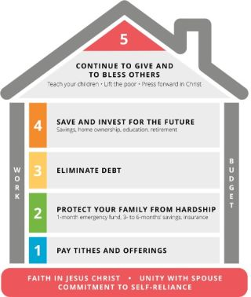

* Paying Tithing and Offerings
  + Bishop Jason Summers (3rd Ward)
* Paying Tithes and Offerings First
* Video – [Obedience Brings Blessings](https://www.bing.com/videos/search?q=srs.lds.org%2fvideos&qpvt=srs.lds.org%2fvideos&view=detail&mid=CC0DB01DD5DF34984DE4CC0DB01DD5DF34984DE4&&FORM=VRDGAR&ru=%2Fvideos%2Fsearch%3Fq%3Dsrs.lds.org%252fvideos%26qpvt%3Dsrs.lds.org%252fvideos%26FORM%3DVDRE) – President Thomas S. Monson
* Change Your Approach to Managing Money

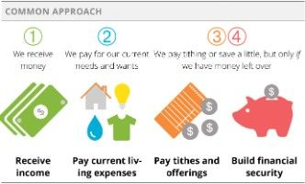

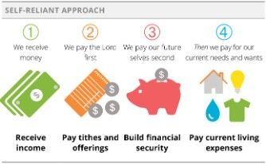

* The rest of the program
  + President David Keller (Stake Presidency First Counselor)
* Elimination of Debt/Creating and Sticking to a Budget – Bother Bob Harris (Stake Self Reliance Coordinator)
* Building a Budget
* Video – [Continue in Patience](https://www.bing.com/videos/search?q=srs.lds.org%2fvideos&&view=detail&mid=16935028EA5986F7CE1C16935028EA5986F7CE1C&&FORM=VRDGAR&ru=%2Fvideos%2Fsearch%3Fq%3Dsrs.lds.org%252fvideos%26qpvt%3Dsrs.lds.org%252fvideos%26FORM%3DVDRE) – Elder Dieter F. Uchtdorf
* Sample budget worksheet

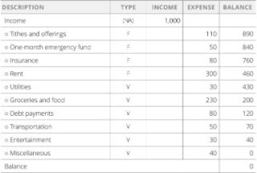

* Handout – Sample Budget

[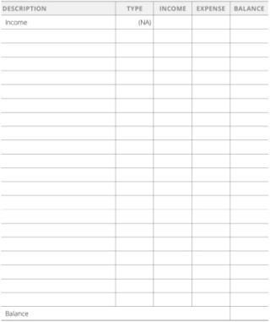](https://www.lds.org/bc/content/shared/content/images/gospel-library/manual/PD60003799/Finance_60.pdf)

* Balancing a Budget
* Variable vs. Fixed Expenses
* Sticking to a Budget
* Video – [A Bigger Truck](https://www.bing.com/videos/search?q=srs.lds.org%2fvideos&qpvt=srs.lds.org%2fvideos&view=detail&mid=983931CD1DF78C73C922983931CD1DF78C73C922&&FORM=VRDGAR&ru=%2Fvideos%2Fsearch%3Fq%3Dsrs.lds.org%252fvideos%26qpvt%3Dsrs.lds.org%252fvideos%26FORM%3DVDRE) – President Dallin H. Oaks
* Setting Realistic, Motivating Financial Goals
* Find and Use a Budgeting System
  + The Envelope System
  + Digital systems
  + YNAB
  + EveryDollar
  + Hold Yourself Accountable
  + Seek the Lord’s Help and Keep Trying
* Protecting your Family from Harm
  + President David Keller (Stake Presidency First Counselor)
* Building a One-Month Emergency Fund
* Acquire Adequate Insurance
* Life Insurance
* Disability Insurance
* Homeowners, Renters, and Automobile Insurance
* Learn to Manage Financial Crises
* Assess the Situation
* Take Action
* Call your Insurance Company
* User your Emergency Fund
* Pay Your Most Important Expenses and Bills First
* Call Your Creditors
* Identify Other Resources That Can Help

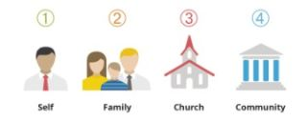

* Self
* Family
* Church
* Community
* Increase Your Emergency Preparations
* Build a Three to Six Mound Emergency Fund
* Learn to understand Debt
* Reduce Debt
* Closing remarks/ Continue to Give and Bless Others
  + President Charles Acevedo (Stake President)
* What Matters Most
* Share what you have learned
* Video – [Creating Lift](https://www.bing.com/videos/search?q=srs.lds.org%2fvideos&&view=detail&mid=5764F0D5BE0A922CD4745764F0D5BE0A922CD474&&FORM=VRDGAR&ru=%2Fvideos%2Fsearch%3Fq%3Dsrs.lds.org%252Fvideos%26qs%3Dn%26form%3DQBVR%26sp%3D-1%26pq%3Dsrs.lds.org%252Fvideos%26sc%3D1-18%26sk%3D%26cvid%3D9AF00E32FEFB44829DFFC11466F343DA) – Elder Dieter F. Uchtdorf
* Elisha and the Widow of Zarephath (1 Kings 17: 8-16)
* Sharing what you have.
* Benediction – TBD

# Resources

“Resources,” Personal Finances for Self-Reliance (2017), 83–86

## The Envelope System

The cash envelope system is simple: immediately after being paid, you place the amount of money you have allotted to spend in each budget category into its own envelope.

For example, let’s say you have budgeted 400 for the “groceries” category this month. When you receive your pay for the month or for the next few weeks, deposit that amount (in cash) into an envelope labeled “Groceries.” No money—and this means no money—comes out of that envelope except to pay for food. If you go to the market and find you’ve left the envelope at home, go home and get the envelope! Keep a written record (in a simple notebook) of all expenses, so that you can later review it during your [family](http://www.mormon.org/values/family) council to remind you where your money is going.

In another envelope, place the budgeted amount for your transportation expenses. You will take from this second envelope when appropriate the portion needed for those costs, and track each expense in your notebook.

Divide each of your budget categories in this same way: rent or mortgage payment in one envelope; utilities in another; [tithing](https://lds.org/topics/tithing?lang=eng) and fast offerings in another; medical; insurance; and so on—each in its own envelope.

Each time you get paid, deposit the appropriate portion of your monthly budgeted amount into each envelope so that the total amount placed in each envelope each month is the amount predetermined in your written budget.

Do not spend more than you have budgeted. When the envelope is empty, you are done! If you must spend more in that category, you will have to take it out of another envelope. For the first few months this will require adjustments. Within that period you should gain a more accurate picture of whether your initial budgeted numbers are adequate—you’ll learn the real average over a couple of months.

Some use the envelope system for everything. Others use this cash-only system for those categories that tend to tempt them to overspend, or for which it is easy to lose track or lose control, like food, restaurants, entertainment, gasoline, and clothing. Any leftover should go toward your financial priority.

**Back to page 77.**

## Digital Systems

If seeing extra cash tempts you to spend more than you otherwise would, then using a debit card may be your best option. As with the cash envelope method, a debit card draws from money already in your bank account.

When using a debit card, it is critical to track your expenses because, unlike the cash-envelope system, a debit card does not provide hard boundaries between budget categories. You can record your expenses with a pen and paper or with a mobile phone or computer application.

Numerous financial management apps are available for cell phones or other mobile devices. These apps can store and organize information for you, and you can then access it from your home computer or other devices, as well.

Spend some time this week researching the best apps available in your language and region, using “money management,” “personal finance tools,” or “budgeting apps” as search terms. Many very good ones are free or cost very little.

Remember, to keep your information secure, access your personal financial information only from your own devices, not from public computers.

**Back to page 78.**